Week 5-Hands on : Microservices with API gateway

Creating Microservice for account:

* Implementing controller method for getting account details based on account number
* First creating the Account class

File name: Account.java

package com.cognizant.account.Model;

public class Account {

private String number;

private String type;

private double balance;

public Account(String number , String type , double balance){

this.number=number;

this.type=type;

this.balance=balance;

}

public String getNumber(){

return number;

}

public String getType(){

return type;

}

public double getBalance(){

return balance;

}

}

* Controller class for handling the request

File name: AccountController.java

package com.cognizant.account.Contoller;

import com.cognizant.account.Model.Account;

import org.springframework.http.ResponseEntity;

import org.springframework.web.bind.annotation.GetMapping;

import org.springframework.web.bind.annotation.PathVariable;

import org.springframework.web.bind.annotation.RequestMapping;

import org.springframework.web.bind.annotation.RestController;

@RestController

@RequestMapping("/accounts")

public class AccountController {

@GetMapping("{number}")

public Account getAccountDetails(@PathVariable String number){

return new Account(number , "savings" , 234344);

}

}

OUTPUT:

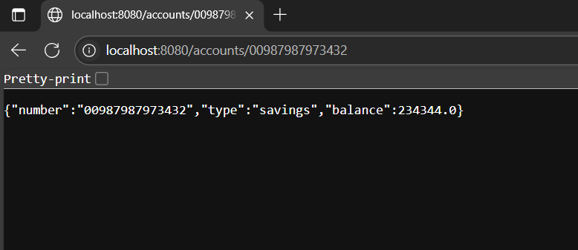

Creating Microservice for loan:

* Implementing controller method getting loan details based on account number
* First creating the Account class

File name: Account.java:

package com.cognizant.loan.Model;

public class Account {

private String number;

private String type;

private double loan;

private double emi;

private int tenure;

public Account(String number, String type, double loan, double emi, int tenure) {

this.number = number;

this.type = type;

this.loan = loan;

this.emi = emi;

this.tenure = tenure;

}

public String getNumber() {

return number;

}

public String getType() {

return type;

}

public double getLoan() {

return loan;

}

public double getEmi() {

return emi;

}

public int getTenure() {

return tenure;

}

}

* Controller class for handling the request

File name: LoanController.java

package com.cognizant.loan.Controller;

import com.cognizant.loan.Model.Account;

import org.springframework.web.bind.annotation.GetMapping;

import org.springframework.web.bind.annotation.PathVariable;

import org.springframework.web.bind.annotation.RequestMapping;

import org.springframework.web.bind.annotation.RestController;

@RestController

@RequestMapping("/loans")

public class LoanController {

@GetMapping("{number}")

public Account getLoan(@PathVariable String number){

return new Account(number , "car" , 40000 , 15000 , 18);

}

}

* Changing the server property to 8081 because we already have an Account service is already using the port 8080

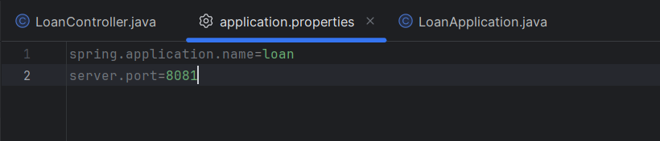

OUTPUT:

